The Traveller

**The Wonders of New York City**

By James Macgillivray

**Introduction:**

New York, the heart of the United States of America, is the biggest, most fantastical city I’ve ever been to. In this article we’ll take look into everything you’re gonna need to travel to this amazing place.

**How to Get to New York:**

If you live in Australia like I do, travelling to the United States can be quite an expensive journey costing about two thousand Australian dollars from either Sydney or Melbourne. The flight will also be a long one, lasting up to a day and a half. This means once you arrive there is a good chance you will have bad jet lag, so you should plan light activities for the first day or so.

**Important Tourist Attractions**

* Statue of Liberty
  + The most famous statue in the world at 46 metres tall, this art piece can be seen all around the upper bay region and is an iconic part of New York City

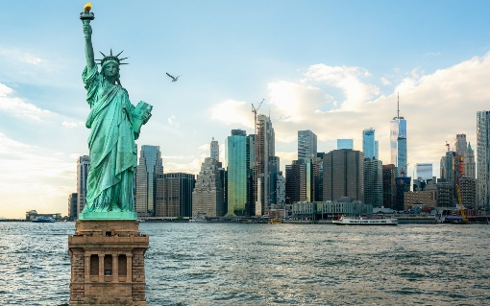

* Empire State Building
  + This one is probably the most famous building in the world, built almost a century ago it still stands tall above almost every other building in NYC…almost
* One World Trade Centre
  + The tallest building in the United States 50% taller than the Empire State Building almost half a kilometre from the ground. This is truly an unforgettable experience
* Central Park
  + This oasis from the concrete jungle of inner-city New York can be a refreshing and fascinating place. The massive 843-acre reserve includes a zoo, a lake and many other attractions.

**Accommodation**

If you are going to go to NYC, you need to have a nice place to rest and recuperate for the busy days ahead. The hotels in New York are stunning but do come at price. This option will heavily depend on your budget, but I would personally recommend the Homewood Suites by Hilton for its proximity to the city centre and times square and reasonable price.

**Food**

The food of NYC is second to none in its quality and quantity. Be warned: portion sizes are massive so be prepared to eat buy smaller servings or indulge in great city food. Some famous cuisine found in the metropolis include New York-style pizza, eggs benedict, hotdogs, and baked pretzels.

**Words of Advice**

NYC is an enormous place and is easy to get lost it. This, however, depends on how you look at it could be a positive or negative experience. You should decide if you like this type ofadventure and if you do not, you should book a tour guide to escort you from place to place. This can be useful for some attractions, especially historical ones, as they usually offer interesting insights even if you are comfortable around bustling cities.

**Conclusion**

NYC is a place everyone should visit at least once in their lives due to its incredible sights, world significance and exciting attractions. I had so much fun going, and you will too.